Create a privacy-enabled network

* Install Prerequisites (Windows)
  + Install Tessera
    - Run Tessera from Docker Image:

docker **run** quorumengineering/tessera:latest 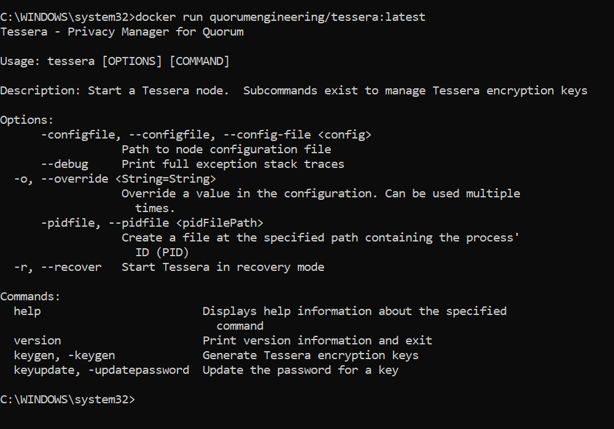

* Create a privacy-enabled network
  + Create a Tessera Directory inside each Node Directory

PS C:\WINDOWS\system32> cd C:\Users\Admin\Documents\Projects\IBFT-Documentation\Node-1  
PS C:\Users\Admin\Documents\Projects\IBFT-Documentation\Node-1> mkdir Tessera  
  
  
 Directory: C:\Users\Admin\Documents\Projects\IBFT-Documentation\Node-1  
  
  
Mode LastWriteTime Length Name  
---- ------------- ------ ----  
d----- 13/9/2022 11:02 pm Tessera  
  
  
PS C:\Users\Admin\Documents\Projects\IBFT-Documentation\Node-1> cd C:\Users\Admin\Documents\Projects\IBFT-Documentation\Node-2  
PS C:\Users\Admin\Documents\Projects\IBFT-Documentation\Node-2> mkdir Tessera  
  
  
 Directory: C:\Users\Admin\Documents\Projects\IBFT-Documentation\Node-2  
  
  
Mode LastWriteTime Length Name  
---- ------------- ------ ----  
d----- 13/9/2022 11:02 pm Tessera  
  
  
PS C:\Users\Admin\Documents\Projects\IBFT-Documentation\Node-2> cd C:\Users\Admin\Documents\Projects\IBFT-Documentation\Node-3  
PS C:\Users\Admin\Documents\Projects\IBFT-Documentation\Node-3> mkdir Tessera  
  
  
 Directory: C:\Users\Admin\Documents\Projects\IBFT-Documentation\Node-3  
  
  
Mode LastWriteTime Length Name  
---- ------------- ------ ----  
d----- 13/9/2022 11:02 pm Tessera  
  
  
PS C:\Users\Admin\Documents\Projects\IBFT-Documentation\Node-3> cd C:\Users\Admin\Documents\Projects\IBFT-Documentation\Node-4  
PS C:\Users\Admin\Documents\Projects\IBFT-Documentation\Node-4> mkdir Tessera  
  
  
 Directory: C:\Users\Admin\Documents\Projects\IBFT-Documentation\Node-4  
  
  
Mode LastWriteTime Length Name  
---- ------------- ------ ----  
d----- 13/9/2022 11:03 pm Tessera

PS C:\Users\Admin\Documents\Projects\IBFT-Documentation\**Node-4**> cd C:\Users\Admin\Documents\Projects\IBFT-Documentation PS C:\Users\Admin\Documents\Projects\IBFT-Documentation> tree  
Folder PATH listing for volume Windows-SSD  
Volume serial **number** is A857-E874  
C:.  
├───networkFiles  
│ └───keys  
│ ├───0x33059f0475495ce974c36df6d8fce13b8577d5e1  
│ ├───0x50aa0543e88b2dedff97ff5c54da3dfce91d67d5  
│ ├───0x9b160a5f5c58ea7cfb9c38582ef802b3a72947da  
│ └───0xd0ae027c05628694f063db4d373131181a783591  
├───**Node-1**  
│ ├───data  
│ └───Tessera  
├───**Node-2**  
│ ├───data  
│ └───Tessera  
├───**Node-3**  
│ ├───data  
│ └───Tessera  
└───**Node-4**  
 ├───data  
 └───Tessera

* + Install Docker Desktop for Windows and copy the container id to copy and paste the private keys to your local file explorer

(<https://www.docker.com/products/docker-desktop/>)

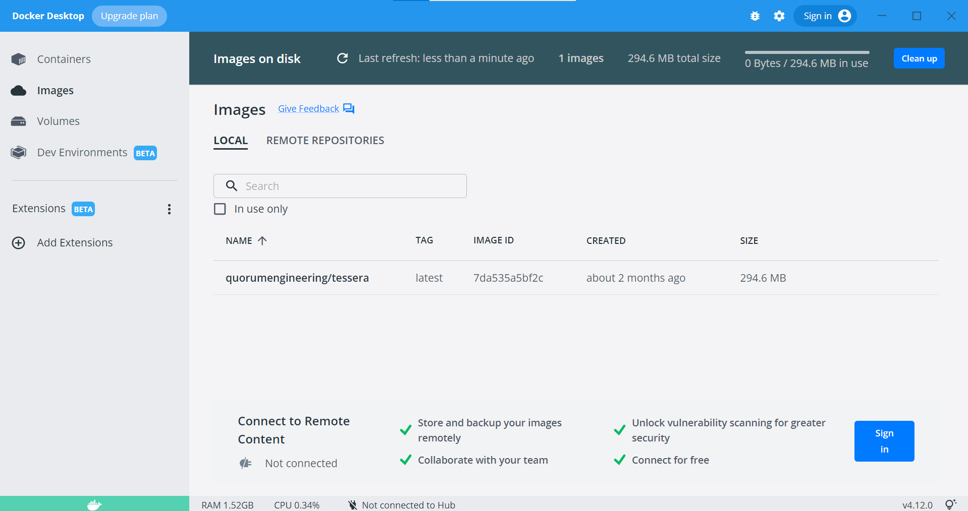

After running this,

docker **run** quorumengineering/tessera:latest -keygen -filename nodeKey

A container id should appear, you may copy the Container id from Docker Desktop for your next step 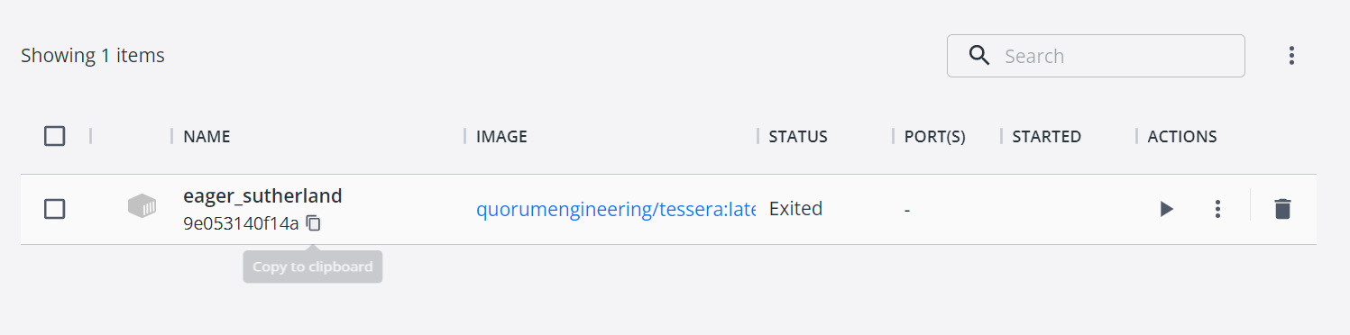

* + Generate a Tessera public/private key pair in each Tessera Directory (Using Docker Image)

PS C:\Users\Admin\Documents\Projects\IBFT-Documentation> docker run quorumengineering/tessera:latest -keygen -filename nodeKey  
Enter a password if you want to lock the private key or leave blank  
Please re-enter the password (or lack of) to confirm  
2022-09-13 15:33:53.057 [main] INFO c.q.t.encryption.nacl.jnacl.Jnacl - Generating new keypair...  
2022-09-13 15:33:53.075 [main] INFO c.q.t.encryption.nacl.jnacl.Jnacl - Generated new key pair with public key PublicKey[9jXSp4ysqvqmemZEz5k77QQpGfXuNv/ExQAv5w+ZwiA=]  
1 keypair(s) generated:  
 1: type=file, pub=9jXSp4ysqvqmemZEz5k77QQpGfXuNv/ExQAv5w+ZwiA=  
 pub: path=/nodeKey.pub  
 prv: path=/nodeKey.key  
PS C:\Users\Admin\Documents\Projects\IBFT-Documentation> docker cp 6ec5ca98a48ba391d7270a7f24176c40ffa5d103d0315d94accdb8224276a149:/nodeKey.pub C:\Users\Admin\Documents\Projects\IBFT-Documentation\Node-1\Tessera  
PS C:\Users\Admin\Documents\Projects\IBFT-Documentation> docker cp 6ec5ca98a48ba391d7270a7f24176c40ffa5d103d0315d94accdb8224276a149:/nodeKey.key C:\Users\Admin\Documents\Projects\IBFT-Documentation\Node-1\Tessera  
PS C:\Users\Admin\Documents\Projects\IBFT-Documentation> docker run quorumengineering/tessera:latest -keygen -filename nodeKey  
Enter a password if you want to lock the private key or leave blank  
Please re-enter the password (or lack of) to confirm  
2022-09-13 15:38:39.822 [main] INFO c.q.t.encryption.nacl.jnacl.Jnacl - Generating new keypair...  
2022-09-13 15:38:39.841 [main] INFO c.q.t.encryption.nacl.jnacl.Jnacl - Generated new key pair with public key PublicKey[AP6mhsLs0cMFqey+OOj67BL5/v67lRtVDc8eWKHtgxI=]  
1 keypair(s) generated:  
 1: type=file, pub=AP6mhsLs0cMFqey+OOj67BL5/v67lRtVDc8eWKHtgxI=  
 pub: path=/nodeKey.pub  
 prv: path=/nodeKey.key  
PS C:\Users\Admin\Documents\Projects\IBFT-Documentation> docker cp 86157aa7837e3a298fe3a9f6273f45d464772fc61cfe1a1e739bc06511a9e25a:/nodeKey.pub C:\Users\Admin\Documents\Projects\IBFT-Documentation\Node-2\Tessera  
PS C:\Users\Admin\Documents\Projects\IBFT-Documentation> docker cp 86157aa7837e3a298fe3a9f6273f45d464772fc61cfe1a1e739bc06511a9e25a:/nodeKey.key C:\Users\Admin\Documents\Projects\IBFT-Documentation\Node-2\Tessera  
PS C:\Users\Admin\Documents\Projects\IBFT-Documentation> docker run quorumengineering/tessera:latest -keygen -filename nodeKey  
Enter a password if you want to lock the private key or leave blank  
Please re-enter the password (or lack of) to confirm  
2022-09-13 15:39:42.693 [main] INFO c.q.t.encryption.nacl.jnacl.Jnacl - Generating new keypair...  
2022-09-13 15:39:42.711 [main] INFO c.q.t.encryption.nacl.jnacl.Jnacl - Generated new key pair with public key PublicKey[WtJygPYusROtgdCVcOUqQ9wlU14WxkT9Cdqli+eQi1M=]  
1 keypair(s) generated:  
 1: type=file, pub=WtJygPYusROtgdCVcOUqQ9wlU14WxkT9Cdqli+eQi1M=  
 pub: path=/nodeKey.pub  
 prv: path=/nodeKey.key  
PS C:\Users\Admin\Documents\Projects\IBFT-Documentation> docker cp 645c1673400377cfeb7afa973966099c8ec96f836ba5ae9a295c376a0eb6f56e:/nodeKey.pub C:\Users\Admin\Documents\Projects\IBFT-Documentation\Node-3\Tessera  
PS C:\Users\Admin\Documents\Projects\IBFT-Documentation> docker cp 645c1673400377cfeb7afa973966099c8ec96f836ba5ae9a295c376a0eb6f56e:/nodeKey.key C:\Users\Admin\Documents\Projects\IBFT-Documentation\Node-3\Tessera  
PS C:\Users\Admin\Documents\Projects\IBFT-Documentation> docker run quorumengineering/tessera:latest -keygen -filename nodeKey  
Enter a password if you want to lock the private key or leave blank  
Please re-enter the password (or lack of) to confirm  
2022-09-13 15:41:00.591 [main] INFO c.q.t.encryption.nacl.jnacl.Jnacl - Generating new keypair...  
2022-09-13 15:41:00.609 [main] INFO c.q.t.encryption.nacl.jnacl.Jnacl - Generated new key pair with public key PublicKey[GPFh5J+5WDKLuit1vOAuh8mFsjjOprT4puOCgxyJslQ=]  
1 keypair(s) generated:  
 1: type=file, pub=GPFh5J+5WDKLuit1vOAuh8mFsjjOprT4puOCgxyJslQ=  
 pub: path=/nodeKey.pub  
 prv: path=/nodeKey.key  
PS C:\Users\Admin\Documents\Projects\IBFT-Documentation> docker cp 34a3b426e5ee6514916ac6984c109ef0fe9b622d2b1ad6a03be9b0fda23c22ec:/nodeKey.pub C:\Users\Admin\Documents\Projects\IBFT-Documentation\Node-4\Tessera  
PS C:\Users\Admin\Documents\Projects\IBFT-Documentation> docker cp 34a3b426e5ee6514916ac6984c109ef0fe9b622d2b1ad6a03be9b0fda23c22ec:/nodeKey.key C:\Users\Admin\Documents\Projects\IBFT-Documentation\Node-4\Tessera  
PS C:\Users\Admin\Documents\Projects\IBFT-Documentation>

* + Create Tessera Configuration Files
    - In the Tessera directory, create a file called tessera.conf on VS Code for each node and input the following codes from this link for nodes 1 to 4

<https://besu.hyperledger.org/en/stable/private-networks/tutorials/privacy/#3-create-tessera-configuration-files>

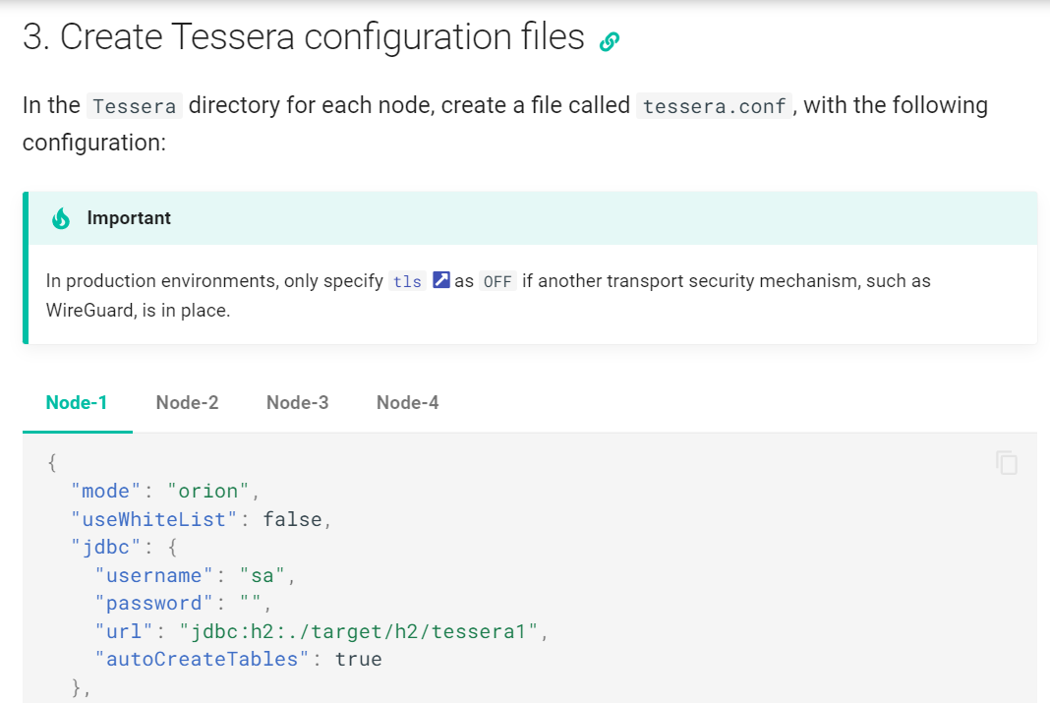

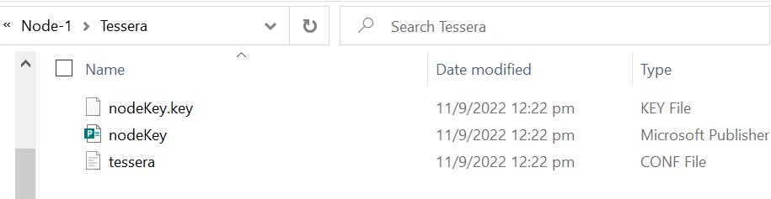

(Skipped Step 4; Running Tessera Nodes, since it is only for testing and we are able to run the Tessera nodes directly through our Besu Config Commands when running our bootnodes for our existing private blockchain)

* + Run the Bootnodes
    - Node 1
      * besu --data-path=data --genesis-file=..\genesis.json --rpc-http-enabled --rpc-http-api=ETH,NET,IBFT,EEA,PRIV --host-allowlist="*" --rpc-http-cors-origins="all" --privacy-enabled --privacy-url=http://127.0.0.1:9102 --privacy-public-key-file=Tessera\nodeKey.pub --min-gas-price=0
    - Node 2
      * besu --data-path=data --genesis-file=..\genesis.json --bootnodes=<Node-1 Enode URL> --p2p-port=30304 --rpc-http-enabled --rpc-http-api=ETH,NET,IBFT,EEA,PRIV --host-allowlist="*" --rpc-http-cors-origins="all" --rpc-http-port=8546 --privacy-enabled --privacy-url=http://127.0.0.1:9202 --privacy-public-key-file=Tessera\nodeKey.pub --min-gas-price=0
    - Node 3
      * besu --data-path=data --genesis-file=..\genesis.json --bootnodes=<Node-1 Enode URL> --p2p-port=30305 --rpc-http-enabled --rpc-http-api=ETH,NET,IBFT,EEA,PRIV --host-allowlist="*" --rpc-http-cors-origins="all" --rpc-http-port=8547 --privacy-enabled --privacy-url=http://127.0.0.1:9302 --privacy-public-key-file=Tessera\nodeKey.pub --min-gas-price=0
    - Node 4
      * besu --data-path=data --genesis-file=..\genesis.json --bootnodes=<Node-1 Enode URL> --p2p-port=30306 --rpc-http-enabled --rpc-http-api=ETH,NET,IBFT,EEA,PRIV --host-allowlist="*" --rpc-http-cors-origins="all" --rpc-http-port=8548 --privacy-enabled --privacy-url=http://127.0.0.1:9402 --privacy-public-key-file=Tessera\nodeKey.pub --min-gas-price=0
  + Enable Websocket connection
    - Update bootnodes 1 to 4 with rpc-ws
    - Node 1
      * besu --data-path=data --genesis-file=..\genesis.json --rpc-http-host=0.0.0.0 --rpc-http-enabled --rpc-http-api=ETH,NET,IBFT,EEA,PRIV --host-allowlist="*" --rpc-http-cors-origins="all" --privacy-enabled --privacy-url=http://127.0.0.1:9102 --privacy-public-key-file=Tessera\nodeKey.pub --min-gas-price=0 --rpc-ws-enabled=true --rpc-ws-host=0.0.0.0 --rpc-ws-port=9545
    - Node 2
      * besu --data-path=data --genesis-file=..\genesis.json --bootnodes=enode://a32b7b959c0acc4fda78814f1261ab964b535a7e63f25f9fd149b391a016297c7f8b200b9e8a90790904ac0e68ff9c31c7fae63dca866a2e4080a314c7bebe86@127.0.0.1:30303 --p2p-port=30304 --rpc-http-host=0.0.0.0 --rpc-http-enabled --rpc-http-api=ETH,NET,IBFT,EEA,PRIV --host-allowlist="*" --rpc-http-cors-origins="all" --rpc-http-port=8546 --privacy-enabled --privacy-url=http://127.0.0.1:9202 --privacy-public-key-file=Tessera\nodeKey.pub --min-gas-price=0 --rpc-ws-enabled=true --rpc-ws-host=0.0.0.0 --rpc-ws-port=9546
    - Node 3
      * besu --data-path=data --genesis-file=..\genesis.json --bootnodes=enode://a32b7b959c0acc4fda78814f1261ab964b535a7e63f25f9fd149b391a016297c7f8b200b9e8a90790904ac0e68ff9c31c7fae63dca866a2e4080a314c7bebe86@127.0.0.1:30303 --p2p-port=30305 --rpc-http-host=0.0.0.0 --rpc-http-enabled --rpc-http-api=ETH,NET,IBFT,EEA,PRIV --host-allowlist="*" --rpc-http-cors-origins="all" --rpc-http-port=8547 --privacy-enabled --privacy-url=http://127.0.0.1:9302 --privacy-public-key-file=Tessera\nodeKey.pub --min-gas-price=0 --rpc-ws-enabled=true --rpc-ws-host=0.0.0.0 --rpc-ws-port=9547
    - Node 4
      * besu --data-path=data --genesis-file=..\genesis.json --bootnodes=enode://a32b7b959c0acc4fda78814f1261ab964b535a7e63f25f9fd149b391a016297c7f8b200b9e8a90790904ac0e68ff9c31c7fae63dca866a2e4080a314c7bebe86@127.0.0.1:30303 --p2p-port=30306 --rpc-http-host=0.0.0.0 --rpc-http-enabled --rpc-http-api=ETH,NET,IBFT,EEA,PRIV --host-allowlist="*" --rpc-http-cors-origins="all" --rpc-http-port=8548 --privacy-enabled --privacy-url=http://127.0.0.1:9402 --privacy-public-key-file=Tessera\nodeKey.pub --min-gas-price=0 --rpc-ws-enabled=true --rpc-ws-host=0.0.0.0 --rpc-ws-port=9548
  + Enable Gasless Transactions
    - In the genesis.json file, set the block size to the maximum

{  
 "config": {  
 ....  
 },  
 ...  
 "gasLimit": "0x1fffffffffffff",  
 ....  
}

* + - In the config section, set the contract size limit to the maximum

(  
 "config": {  
 ...  
 "contractSizeLimit": 2147483647,  
 ...  
 }  
 ...  
}

* + - Start Besu Nodes with a minimum gas price of zero (if you haven’t)

--min-gas-price=0

